http://www.brainstation-23.com/ecommerce-web-development-frontend-backend-web-technologies/:

Ecommerce Web Development: Understanding Frontend and Backend Web Technologies
by Asma Swapna 10 Oct, 2017
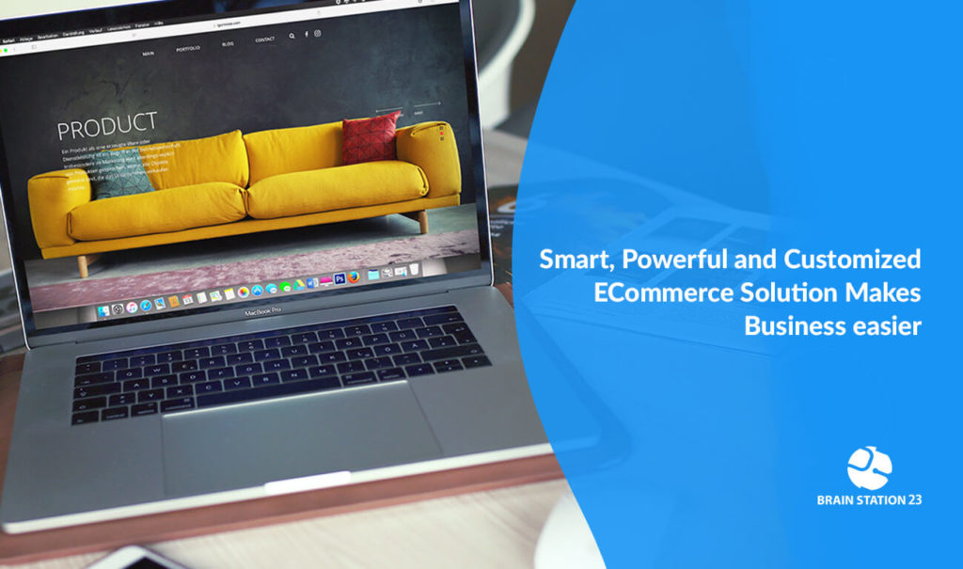In the ever challenging and competitive commerce business, the experience of the users of the services provided is what makes the profit. Online commerce is all about serving better, serving easy and gain trust to retain customers. To keep your steps ahead of others, online business owners adopt the newest technologies to appear at its best in front of the customers. Since, the only thing ecommerce customers see is, is the website or mobile apps they use to take purchase decision, the fight lies in there. Everyone wants to make their website or mobile app lucrative, easy to navigate and operative in seconds whenever customers want. Sinc it’s an era of going mobile, websites need to be more functional to fight the battle than previous. Hence, ecommerce web development is of importance for the companies developing the ecommerce software and the owners of the online business at the same time.

Web Technologies and Ecommerce Business
Online shopping drives a huge share of retail sales these days, and getting the products online and available to the world is one of the fastest ways to start building your business, brand, and revenue. Whether you’re a small business establishing an e-commerce site for the first time, or you’re a larger merchant looking to streamline your existing online and brick-and-mortar experiences. And there are a number of platforms available to suit your specific needs on both client and server sides.
Hence, ecommerce web development is of two faces: one is the frontend and backend is the other. In any ecommerce website development process, all the best ecommerce web design company follow a certain group of technologies to standout their feature lists work perfectly at the user end. While others find it difficult enough to build a proper UX preferred ecommerce website development, the top companies follow the agile method to sustain as a lead. Let’s hear out of the technologies used in topnotch software development companies for ecommerce business.

Front-End Ecommerce Technologies
Frontend is what appears on the user’s side most and what entices the users to give the website a stroll. Hence, the designers work at the base level of this process. The UI designer and UX engineer both works collaboratively to make the website appear at its best with less delay and amazing easy to navigate functionalities. The aim to choose the most creative and useful technologies are:
- Make the website look great
- Build the website to load faster
- Increase responsiveness and device portability
With use of advanced technologies and smart creative minds, web development companies start the primary process of ecommerce web development.
Starting from client-side scripting language to design tools everything is collaborated as one big team to develop the best website for your online business. Whereas, front-end scripting languages are the most essential subset of programming languages that perform specific functions within larger object-oriented back-end programming languages such as Java or C#. With the advent of HTML5, Canvas, web application developers now have the smart scripting languages, particularly AJAX and Action-script, incorporated into the most of the all modern browsers like chrome, Firefox, IE10 and more. Dependability on plugins are less nowadays.
However, below is a summary of some of the mostly used Front-end Technologies our developers have expertise in:

HTML
HTML is probably the primary language all the developer’s expertise at the very beginning. The reason is, HTML provides building blocks to all websites, particularly text and images.

JavaScript
Once there is a clear understanding of HTML and the webpage skeleton, there comes the need of enriching the page with more and more content. This is the trickiest part to build a better website for ecommerce business, as we all know content is what the customers look for in the website. Hence, JS is capable of rich user experience for browser-based applications. An expert, skilled and trend-setting JS developer is a must for a ecommerce website development team.

AngularJS
AngularJS is built for dynamic web apps. Since, the introduction and capability of making the website content rather than static, the main fight among the developers began. Newest frameworks and APIs being introduced every once in a while, to support the fight grow rich and more interesting of creative showcase. AngularJS is a structural framework that HTML as the template language.

Node.Js
Node.js is an open source, cross-platform runtime environment for developing server-side and networking applications. Node.js handles the core functionality of server-side JS as a creation of Web servers and networking tools using JavaScript and a collection of modules. As an asynchronous event driven JavaScript runtime, Node is designed to build scalable applications. For ecommerce and network based services Node.JS is the primary choice for the JS developers.

ReactJS
Built and utilized by Facebook, React JS is a fast and flexible JavaScript library that enables the front-end developers to build dynamic user experiences efficiently. All this JS libraries, frameworks are to create smart and faster loading of the content leveraging JS on the webpage to provide seamless user experience. And, ecommerce website development companies hire the bests of the best in the relevant field to make their service, product and solutions leaving unique user experience.

VBScript
Developed by Microsoft, VBScript enhances web functionality with lightweight speed.

Ajax
It’s said Ajax is a developers’ dream; specially for front-end architects and UX designers. The reason probably is that, Ajax allows asynchronous update of the webpage content without reloading the whole page. Henceforth, Ajax gives actions within applications better responsiveness. Ajax is best for action based services. For ecommerce, allowing the actions like filtering the right product, taking customer information, updating the purchase choice, survey run and review processing, Ajax is more reliable to the developers.

JQuery
JQuery a fast, small, and feature-rich JavaScript library. it makes things like html document traversal and manipulation, event handling, animation, and AJAX much simpler.

Responsive Web Design
Responsive web design is nothing but the web design approach aimed at crafting sites to provide an optimal viewing experience including easy reading and navigation with a minimum of resizing.

Twitter Bootstrap
Bootstrap is the most favorable to the developers and users at the same time since it is sleek, intuitive, and powerful front-end framework for faster and easier web development to offer seamless customer experience.

Flash
Flash a multimedia and software platform used for authoring of vector graphics, animation, games and rich internet applications (rias) which can be viewed, played and executed in adobe flash player. For multimedia content access flash is the primary field of expertise for front-end developers.

Back-End Ecommerce Technologies
If the back doesn’t support well, there will be no more standing ecommerce website to survive the competitive market or so it seems. Technologies are pretty complex and boring in back-end. But, the developers know what can make the process more interesting, that is to use right technology to do the right functionality work well.
Let’s talk back-end now, the skeleton behind the beautiful and enticing website we have been building for years.

PHP
Among all other scripting languages, PHP is probably the most popular language for ecommerce web development. Since its pre-installed in almost all hosting services, developers find it convenient and clever choice to build web based services and applications. The classic and popular frameworks among developers’ community, for PHP are Zend Framework and Symfony. Here, at Brain Station have been using CakePHP and Symfony2 for several projects, it was a very good tool or so the developers think. However, nowadays there are many good alternatives, such as Yii and Laravel.
Almost all of the popular open source and proprietary ecommerce platform in business, Magento, BigCommerce, Volusion etc. are built in PHP.

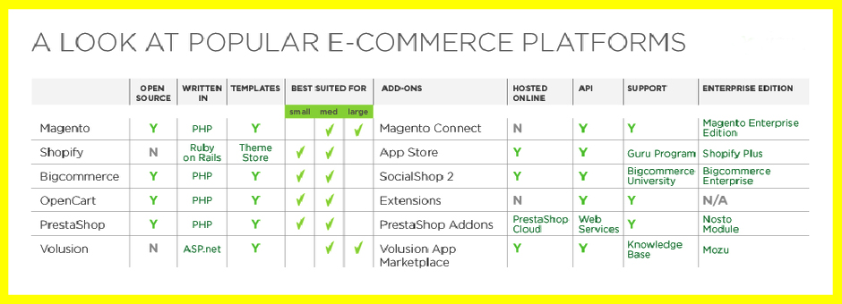

Python
Python language uses a simpler syntax than PHP so one developer group finds it easy to use in webbed services. It’s designed to have a very readable code, and for that reason is very recommended to learn programming. It’s well tested, Google chose it to develop their services, and that’s a good thing. A lots of good amazing open source ecommerce platforms alike Shuup, eComwar, Saleor etc. are built in Python. The frameworks for Python are the most popular for building website’s backend to provide extended functionalities through web services. Among them, the most popular framework for Python is Django, Pyramid, Web2Py!
With the non-stack frameworks, if you want to create a full-featured website, you will need to add a lot of code and extra bits yourself. This takes skill and time. Hence, the frameworks come in.

Java
Java backs most of the popular CMS and developments platforms for ecommerce website development. SAP Hybris, the powerful ecommerce platform for omnichannel B2B businesses is one of them. Other than that, Hippo, Magnolia, Mayocat, Qalingo, Shopizer are a few of example of Java backed CMS and technology to build commerce website for small business to boost sales on the web.

MySQL
MySQL is the most popular DBMS for developing ecommerce websites. Ecommerce is based on lots and lots on content stored in the database to serve the users helping them taking the purchase decision. Hence, the rendering and loading of rightly filtered data is crucial. In this business, MySQL started as a stripped-down tool bringing more speed, although it was adding features until being a complete and fast solution. Since the time, it was purchased by Oracle, there is a fork to keep the project open source called MariaDB.
All the classic systems such as SQL Server, Oracle or DB2 are not so popular among web developers, maybe more for ASP.NET in the case of SQL Server.

PostgreSQL
In the Ruby on Rails community there is a popular alternative for MySQL; that is PostgreSQL. It’s a very powerful and open-source DBMS having interesting additional features such as full text search and a messaging system. Since, it’s so open source, the capability of adding newest and trendy features in it is the work creative and talented developers and contributors. It also has useful data types which integrate with Rails very well. This DBMS is by far the most favorite among the Brain Station 23 developers of ecommerce website development team.

ASP.Net
Now let’s talk about the leading tech in ecommerce field. ASP.Net, so far is the vastly used language. The aspiring ecommerce platform like nopCommerce is built in ASP.Net.
Our developers prefer using ASP.Net for most of their ecommerce website development project unless otherwise is required. Since, all the big platforms ready to empower any ecommerce site are built on ASP.Net, that preference is relevant for making any on demand customization for our valued customers and optimize that for their business growth. Our own built ecommerce websites backed in ASP.Net are among the successful ones in both global and local market. Biponee.com, othoba.com, priyoshop.com, Uvited.com are just a few of them. Why not hover to our portfolio and have a look through to get the big picture and prospects of using ASP.Net for ecommerce!
“A common rule of thumb is that what you’ll get in flexibility from an e-commerce platform, you’ll trade for simplicity”
Hence, it’s important to weigh how much you want from your platform vs. how much development time and energy you’re willing to put into building and maintaining it. Another important consideration is how much you expect to grow over time. This could mean the difference between shopping for a hosted ecommerce cart solution vs. a more integrated platform that’s built on your own frontend & backend software and preferred technologies.
Developers with expertise in both the sides, are the Master and Jack of all things, they are the Full- Stack developers. Knowledge and understanding of trends and technologies in both stacks don’t come in handy that easy rather requires experience and understanding of customer and business owners altogether. The best software development companies how to build a strong team diverse expertise to nail the fight. Brain Station, 23 is such a diverse team of talents and experts at different industries, technologies and field of interests. Our developers are also sincerely adoptive to the newest trends and taste of clients and their users of the ecommerce solutions built in house.
Contact our sales team anytime to know how you can boost your ecommerce business serving a better website to your customers.

